Llywydd  President | Susan Plumb  IRRV (Hons)
Is Lywydd  Vice President | Carwyn Jones  IRRV (Tech)
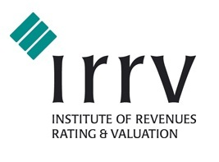

Thursday 27th April 2017
Bod Erw—St Asaph
11.00 am | Registration and Tea/Coffee
11.15 am | Annual General Meeting  - Apologies for Absence  - To approve Minutes of the Meeting held 15 April 2016  - Matters arising  - Presidents Report  - Secretary’s Report  - Treasurers Report and Adoption of Accounts  - Education/ Training Liaison Officers Report  - Election of Officers  - Address by Anne-Marie Read, Senior Management Consultant, Performance Development Team (DWP) – Housing Delivery Division Update  - Any other Business
1.00 pm | Lunch  The President Susan Plumb expresses the wish that you join her and our guest speaker Anne-Marie Read for lunch at the conclusion of the meeting (cost £5 per person).
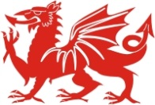
TO ALL ASSOCIATION MEMBERS

The Annual General Meeting of the North and Mid Wales Association will be held on Thursday 27th April 2017.
Cymdeithas Gogledd a Chanolbarth Cymru

North and Mid Wales Association

Annual General Meeting
Speaker Biography – Anne Marie Read, Senior Management Consultant, Performance Development Team (DWP)
Please reply by email to: matthew.evans@wrexham.gov.uk by Wednesday 26th April 2017
Name
Address/Authority
Email
Tel.Number
☐ | I will be attending the meeting on Thursday 27th April 2017 and require a reservation for lunch (please advise if you have any dietary requirements)
☐ | I will be attending the meeting on Thursday 27th April 2017 and do not require a reservation for lunch
☐ | I will not be attending the meeting  (Please click on the box to check/uncheck)

After graduating from Surrey University Anne-Marie joined DWP in 1993 in a variety of operational and Project roles. Most recently delivering Projects involving changes to ESA.
She joined Housing Delivery Division PDT in July 2015 primarily working with LAs to improve performance but has recently been a key enabler for the improvements to the HB fraud referral process.
On a personal note, Anne-Marie has been married for nearly 23 years. She has 2 daughters, Emily who is working in Corporate Banking and Annie who is 8 going on 15. Anne-Marie spends most of her free time either as a foundation school governor or as a catholic Eucharistic minister.

