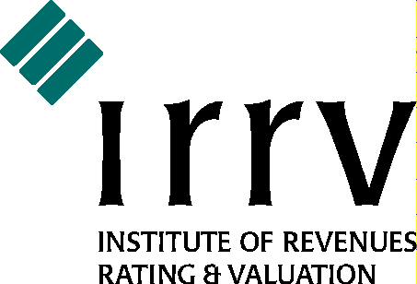

WEST MIDLANDS ASSOCIATION ANNUAL DINNER DANCE

SATURDAY 29 FEBRUARY 2020

For the fifth year running, the IRRV West Midlands Association’s annual dinner dance will be held at the Bromsgrove Hotel and Spa, formerly the Hilton Hotel at Bromsgrove, close to the M5 and M42.
The dress code is formal/black tie.
Tickets for the evening are again £30.00 per person, which includes
- a 3-course meal with wine, followed by tea/coffee
- after-dinner speeches of the highest quality (we hope!)
- an opportunity to win a raffle prize
- a disco
- a casino!
To secure your place(s), please complete and return the booking form overleaf as soon as possible. If you have any special dietary requirements or allergies, these can be catered for – just let us know on the form.
Accommodation
For those wishing to stay overnight, rooms are available at the discounted rate of £75 for a double room or £60 for a single room, to include breakfast, overnight parking, and use of the leisure facilities. Free cancellation is allowed up to the day of the event, and payment will only be taken when you arrive.
This special rate is only available by phoning 0161 923 0300 and quoting IRRV290220 - rates quoted on the web may look cheaper but will not include any of the additional items stated above, and may be non-cancellable and payable in full at the time of booking.
If you require further information, please email us at irrvwma@googlemail.com and we will get back to you as soon as we can.
We look forward to welcoming friends old and new to what will be a great night!
Best wishes,

Neil Jinks
President
IRRV West Midlands Association
IRRV West Midlands Association Annual Dinner Dance
Saturday 29 February 2020
Bromsgrove Hotel and Spa, Bromsgrove B61 0JB
Name | Company (if applicable) | Daytime phone number
Email address | Invoice required? | Order ref. (if required)
Please reserve places for the following:
Guest name | Special dietary requirements (please specify) | Invited guest of Association / Complimentary sponsor place / Paying guests at £30 each (please specify)
Payment should be made to:
Payee IRRV West Midlands Association
Bank HSBC
Sort code 40-43-03
Account number 41141902

Please email your completed form to irrvwma@googlemail.com as soon as possible.

