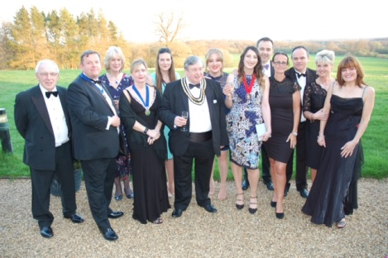

Dear Members,

Welcome to the first newsletter of 2018/19 brought to you by the Thames Valley Association!

The photo taken above contains the majority of the Executive from the association along with a few familiar faces from IRRV HQ. This photo was taken at our annual gala dinner in April which we held with the support of 11 fantastic sponsors. It was a fun evening and we would encourage any members tempted to attend next years dinner to come along, we don’t do too much formality at these dinners – we are more interested in socialising and having fun with friends and colleagues – as demonstrated below!

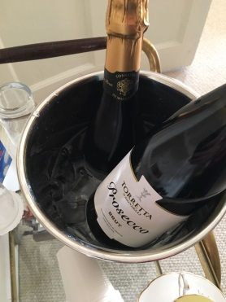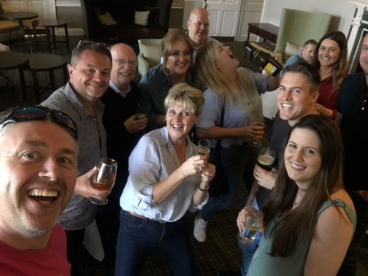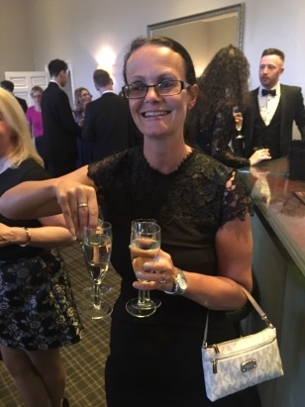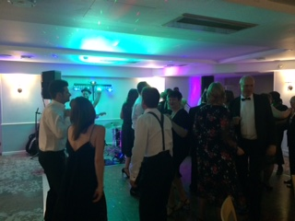

Over the coming year we will be holding four professional training/forum days, a charity challenge, a couple of social events and of course the next gala dinner which will be held on 6th April 2019. We will keep you updated throughout the year with details of these events as they approach.

Training Days

We will be holding four events on a variety of topics at various venues across the Thames Valley. All of these events will be FREE to IRRV members with a minimal charge for non-members – we will also provide a FREE lunch at each one. Please see below for a list of dates and venues. Full details for each one and how to book will be circulated to members closer to the date of each event.

Friday 20th July 2018

Vulnerability, Council Tax Reduction Schemes Presentations and Workshop

Venue: Bracknell Forest Borough Council

Friday 9th November 2018

Digital Delivery for Revenues and Benefits Services

Venue: Wokingham Borough Council

Friday 18th January 2019

Recovery and Enforcement

Venue: Chiltern District Council, Amersham

Friday 5th April 2019

Non-Domestic Rates Forum Day and Association AGM Meeting

Venue: Bracknell Forest Borough Council

Association Charity Challenge

Myself and a number of follow Exec members will be attempting to complete the Yorkshire Three Peaks Challenge in September in aid of my charity for the year which is the RAF Benevolent Fund.
The Yorkshire Three Peaks route is 24 miles (38.6km), and includes 1585m (5200ft) of ascent.
The Challenge takes on the peaks of Pen-y-ghent, Whernside and Ingleborough, and we will be attempting to complete this in under 12 hours.
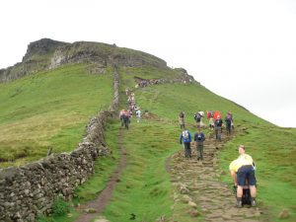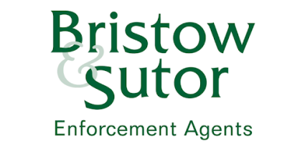

The challenge is kindly being sponsored by Bristow & Sutor Enforcement Agents.

We have set up a just giving page if you wish to support us in completing this challenge for a cause that is very close to my heart. Just click the link below to donate:

https://www.justgiving.com/fundraising/irrv-thames-valley-association

Social Events

As an association we believe in networking of the more relaxed variety and try to put on a couple of social events each year for our members to get to know each other and to make connections at other authorities and companies located within our area. We would really like to see some new faces (as well as the old ones!) at these so please do look out for details and try to come along. This year in addition to the gala dinner we are looking to put on a Christmas social event so look for more details on that!

I think that’s all for now and we will be in touch with further details of events and maybe some more photographs of our pursuits throughout the year. Please feel free to forward this newsletter to colleagues who may not be on our mailing list.

Many thanks and look forward to seeing you during the year.

Sarah Kingston

Thames Valley Association Presiden

